*Topic proposal*

The final words spoken by an individual before death carry a profound significance, often encapsulating the culmination of their experiences, beliefs, and emotions. For this project, we aim to explore the psychological and emotional dimensions reflected in the last words of two distinct groups: executed prisoners and notable public figures. Our interest in this topic stems from a collective fascination with crime shows, where the exploration of the minds of criminals—particularly their psychological and emotional states—serves as a key theme. This interest naturally led us to wonder: how do individuals from vastly different life experiences and circumstances—such as criminals on death row and historically significant figures—confront their final moments?

This project seeks to explore the psychological and emotional dimensions of these last words by comparing the two groups through text mining techniques. By examining the final statements of executed prisoners alongside those of notable people, we aim to identify patterns, contrasts, and common themes in how individuals face the final moments of life. In particular, we will focus on how psychological factors such as guilt, blame, acceptance, and regret differ between these two groups. Our study will delve into the broader philosophical and emotional lessons that may emerge from this comparison, offering insights into the ways individuals confront mortality based on their life experiences and the circumstances surrounding their deaths.

The primary dataset we will use for this exploration comes from the Texas Department of Justice, specifically their "Death Row Information" table, which contains detailed last statements of inmates, along with information about their crimes and convictions. Our secondary dataset will be a curated collection of notable figures’ last words, web-scraped from reputable sources, and paired with context about their lives. Juxtaposing these datasets using text mining and sentiment analysis techniques will allow us to extract semantic patterns and emotional themes expressed in the final words of these individuals, regardless of the length or brevity of their statements.

Key themes such as guilt, blame, and acceptance will form the core of our analyses, enabling us to gain a deeper understanding of how the circumstances of an individual’s life and death influence their emotional state at the time of death. Ultimately, we hope this comparison will reveal meaningful insights into the human condition, offering reflections on how individuals confront mortality, and potentially even shedding light on the values that contribute to a life filled with acceptance versus one filled with regret.

*Sources*

Ward, Laura. *Famous Last Words: The Ultimate Collection of Finales and Farewells*. Sterling Publishing, 2004.

* This collection captures the final statements of various prominent figures, offering both profound and poignant reflections. It is useful for your project as it provides a diverse range of last words that can be compared with the last statements of executed prisoners to identify thematic differences or similarities.

<https://books.google.com/books?id=bpYWQPAGmPUC&pg=PA23#v=onepage&q&f=false>

Marvin, Frederic Rowland. *The Last Words (Real and Traditional) of Distinguished Men and Women: Collected from Various Sources*. Funk & Wagnalls, 1901.

* This book compiles last words of notable figures, offering insight into the emotional and psychological state of historically significant individuals. It is relevant for your project as it provides a well-documented dataset of last words from public figures, which can be analyzed for emotional themes and patterns.

<https://books.google.com/books?id=1TUzAQAAMAAJ>

Bisbort, Alan. *Famous Last Words: Apt Observations, Pleas, Curses, Benedictions, Sour Notes ...*. Pomegranate Communications, 2001.

* Bisbort’s book includes a wide variety of last words, from pleas to curses, allowing for a deep dive into the emotional range expressed by notable individuals. This is relevant for analyzing the tone, acceptance, or regret in notable figures' last moments, essential for comparing with prisoners’ final words.

<https://books.google.com/books?id=DMG5i1UrcyQC&pg=PA18#v=onepage&q&f=false>

Egbert, Walter Raimee. *Last Words of Famous Men and Women*. W.R. Egbert, 1902.

* Egbert’s Last Words of Famous Men and Women provides a compilation of final statements made by historical figures. The book captures a range of emotions, from solemn reflections to witty remarks. It is relevant for your project as it offers a primary source of notable last words for comparative analysis.

<https://books.google.com/books?id=X6gfAQAAMAAJ&dq=Walter+Egbert+Last+Words+of+Famous+Men+and+Women&pg=PA129#v=onepage&q=Walter%20Egbert%20Last%20Words%20of%20Famous%20Men%20and%20Women&f=false>

Brahms, William. *Last Words of Notable People: Final Words of More than 3500 Noteworthy People Throughout History*. Kindle ed., Reference Desk Press, 2010.

* This comprehensive collection provides final words from over 3,500 notable individuals, spanning a wide range of historical periods and professions. For your project, this source is invaluable as it offers a substantial dataset for analyzing the psychological and emotional dimensions of public figures’ last words, enabling thematic comparisons with executed prisoners.

<https://www.amazon.com/dp/B009TJOL5S>

Guthke, Karl S. *Last Words: Variations on a Theme in Cultural History*. Princeton University Press, 1992.

* Guthke's *Last Words: Variations on a Theme in Cultural History* explores the cultural significance and themes surrounding the final words of individuals across different historical and literary contexts. This book is relevant to your project as it provides a scholarly analysis of last words, offering insights into their philosophical and emotional meanings.

Le Comte, Edward S., compiler. *Dictionary of Last Words*. Dodd, Mead & Co., 1969.

* Le Comte's *Dictionary of Last Words* compiles the final statements of notable individuals from various fields, offering a reference-style resource for exploring famous last words. This book is useful for your project as it provides a curated collection of concise final words, ideal for analyzing emotional and psychological patterns.

"Executed Offenders." *Texas Department of Criminal Justice*, [www.tdcj.texas.gov/death_row/dr_executed_offenders.html](http://www.tdcj.texas.gov/death_row/dr_executed_offenders.html). Accessed 9 Oct. 2024.

* This website from the Texas Department of Criminal Justice provides detailed records of executed offenders, including their last statements. It is a critical source for your project as it offers primary data on the final words of inmates, allowing for text mining analysis to compare these with the last words of notable public figures.

Fattizzo, Nick. "20 of the Funniest and Most Ironic Last Words from History." *The History Corner*, [www.thehistorycorner.org/articles-by-the-team/20-of-the-funniest-and-most-ironic-last-words-from-history](http://www.thehistorycorner.org/articles-by-the-team/20-of-the-funniest-and-most-ironic-last-words-from-history).

* This article from The History Corner highlights 20 of the funniest and most ironic last words from notable historical figures. Featuring final quips from figures like Voltaire, Winston Churchill, and Groucho Marx, it offers a lighter, humorous take on how people approach death with wit and irony, often in unexpected ways.

Hirschmüller, Sarah, and Boris Egloff. "A Focused Review of Language Use Preceding Death by Execution." Frontiers in Psychology, vol. 9, 2018, Frontiers Media, https://doi.org/10.3389/fpsyg.2018.00683. Accessed 9 Oct. 2024.

* This review examines studies analyzing final statements of Texas death row inmates. Research shows these statements contain more positive than negative emotions, with prevalent themes of love, spirituality, and social connections. Compared to people imagining imminent death, inmates' words express more positivity and focus more on relationships and religion. This is useful to our study as it provides another psychological viewpoint on our data, which is useful to cross-reference with our text mining.

Foley, S. R., and B. D. Kelly. "Forgiveness, Spirituality and Love: Thematic Analysis of Last Statements from Death Row, Texas (2002–17)." QJM: An International Journal of Medicine, vol. 111, no. 6, June 2018, pp. 399–403, Oxford University Press, https://academic.oup.com/qjmed/article-abstract/111/6/399/4951479?redirectedFrom=fulltext&login=false. Accessed 9 Oct. 2024.

* This study analyzed last statements from Death Row inmates in Texas from 2002 to 2017. Execution rates decreased, while time on death row and age at execution increased. Common themes in statements included love, spirituality, regret, and apology. Over time, requests for forgiveness declined, but love and spirituality remained constant themes. This is useful because it provides a psychological component of analysis to the dataset we are using

Sexton, Lori. Under the Penal Gaze: An Empirical Examination of Penal Consciousness Among Prison Inmates. U.S. Department of Justice, Sept. 2012, https://www.ojp.gov/pdffiles1/nij/grants/239671.pdf. Accessed 9 Oct. 2024.

* This dissertation examines "penal consciousness" among prison inmates, exploring how they perceive and experience punishment. Through interviews with inmates in Ohio prisons, the study analyzes the content, severity, and salience of punishment from inmates' perspectives. It develops a theoretical framework for understanding variations in penal consciousness across different supervision styles and genders.

Kniffin, Kevin M., and Brian Wansink. "Death Row Confessions and the Last Meal Test of Innocence." Laws, vol. 3, no. 1, 2014, pp. 1-11, https://doi.org/10.3390/laws3010001. Accessed 9 Oct. 2024.

<https://doi.org/10.3390/laws3010001>

* This study examines last meals and final statements of death row inmates to explore potential indicators of innocence. The research found that inmates who denied guilt were more likely to decline a last meal, while those who admitted guilt tended to make larger meal requests. Religious references and expressions of love were common in final statements. In addition to corroborating other academic findings, this paper relates the additional data points of the final meal with the death row inmates which is useful to our own study.

Kelly, B. D., and S. R. Foley. "Analysis of Last Statements Prior to Execution: Methods, Themes and Future Directions." *QJM: An International Journal of Medicine*, vol. 111, no. 1, Jan. 2018, pp. 3–6, Oxford University Press,<https://doi.org/10.1093/qjmed/hcx227>. Accessed 9 Oct. 2024.

* This review examines studies of death row inmates' last statements, primarily from Texas. Common themes include love, spirituality, and apology. Psychological constructs like identification-egression and unbearable pain are prevalent. The research highlights high rates of mental illness among death row inmates and calls for more studies from other countries. This is useful to our study as it provides psychological analyses of last statements, which can aid in our own text mining of those statements.

<https://www.tdcj.texas.gov/death_row/dr_executed_offenders.html>

Ashton, Jackson. “People’s last words are often these 4 phrases: What they teach us about living happy, meaningful lives, from an oncologist.” *CNBC*, 31 May 2024, [www.cnbc.com/2024/05/31/phrases-that-are-often-peoples-last-words-says-doctor-what-we-can-learn.html](http://www.cnbc.com/2024/05/31/phrases-that-are-often-peoples-last-words-says-doctor-what-we-can-learn.html).

This article explores common themes and phrases spoken by individuals in their final moments, providing insights into the human psyche at the end of life. Dr. Susan Hegarty, who has extensive experience in end-of-life care, shares her observations on how these phrases reflect acceptance, closure, or unresolved emotions. The piece offers a deeper understanding of how people confront mortality, connecting these expressions to broader psychological and emotional themes. This source can provide valuable context for analyzing last statements in both criminal and non-criminal settings.

<https://github.com/ebemunk/blog/tree/master/projects/2021-02-18-lastwords>

This project sourced data from the Texas Department of Justice’s Death Row Information and the Death Penalty Information Center archives, providing a comprehensive dataset of final statements made by executed inmates. It includes visualizations and analysis tools for understanding these statements in relation to their emotional and psychological contexts. Our project will be complemented by a secondary dataset containing last words of notable public figures, allowing for a comparative analysis of how individuals with different life experiences express emotions like guilt, acceptance, or regret in their final moments.

<https://www.reddit.com/r/dataisbeautiful/comments/mlb71d/oc_last_words_in_texas_i_analyzed_454_last/>

Abstract

The final words spoken by an individual before death carry a profound significance, often encapsulating the culmination of their experiences, beliefs, and emotions. This project seeks to explore the psychological and emotional dimensions reflected in the last words of executed prisoners compared to notable people. By examining these last statements through text mining techniques, we aim to identify patterns, contrasts, and common themes in how individuals face the final moments of life and gain meaningful insights. Specifically, we focus on understanding how psychological factors—such as guilt, blame, and acceptance—differ between these two groups. Given the unique nature of these final statements, this study also explores the broader philosophical and emotional lessons that may emerge from analyzing the last words of those who lived before us. Through this analysis, we hope to uncover insights into the human condition and the ways in which individuals confront mortality.

I thought applying the LDA topic modeling would be good for our project, below is a reference to what we could do:

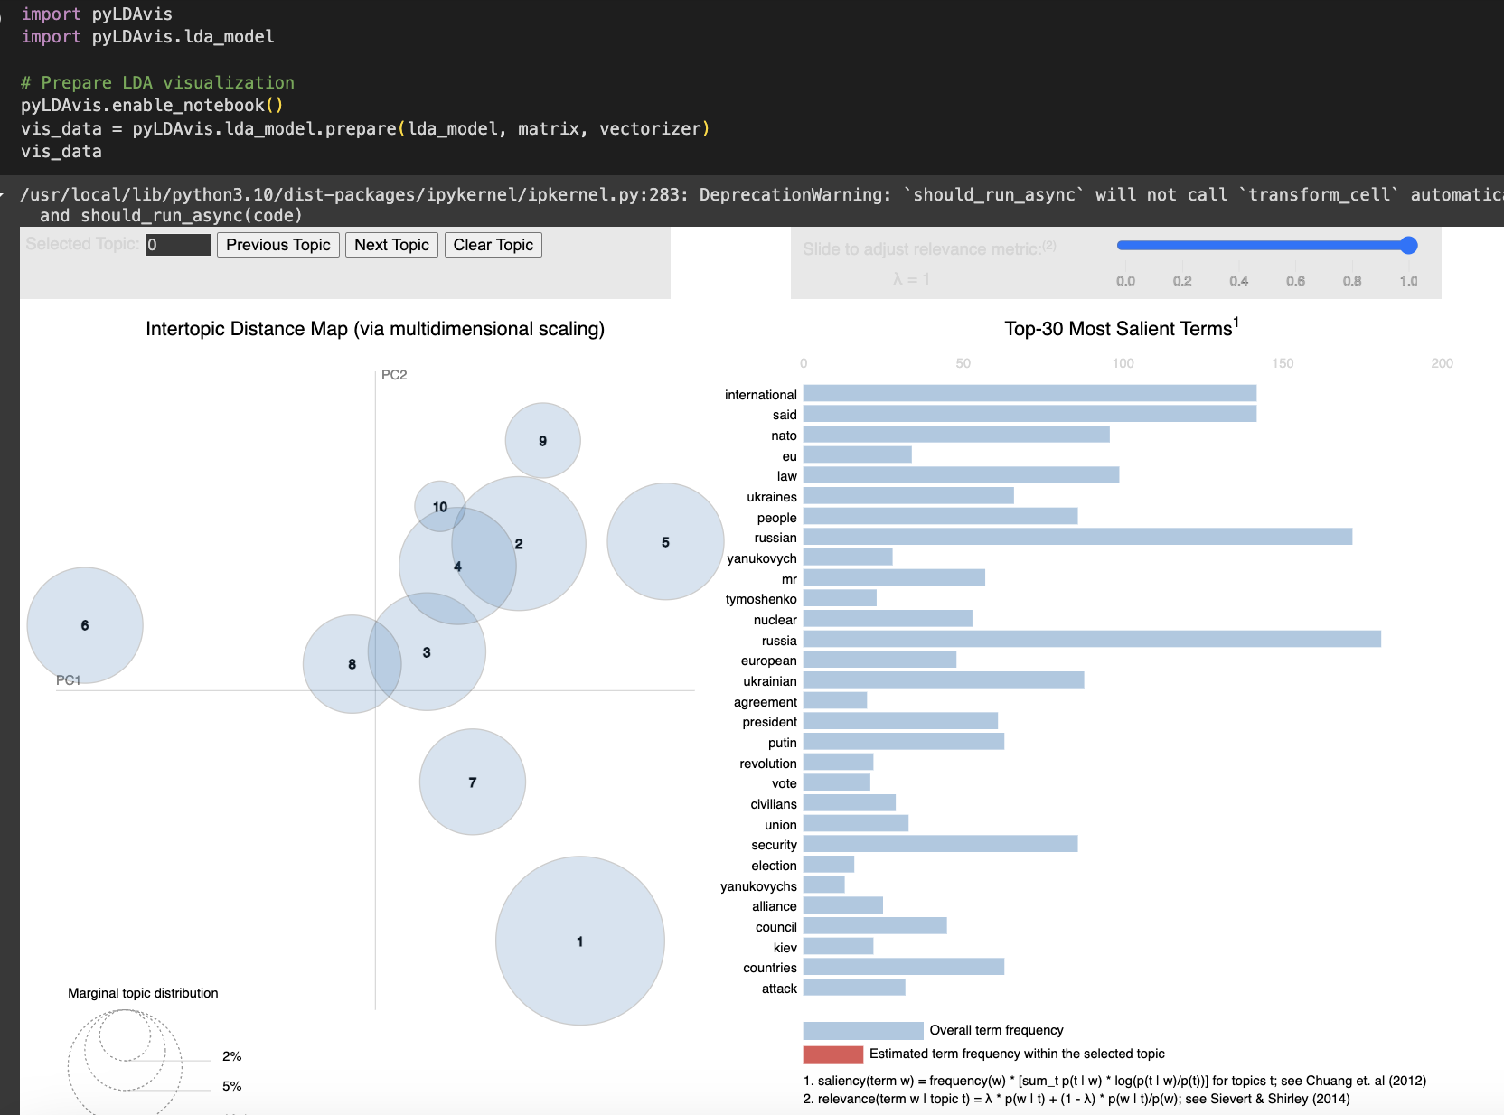

<https://www.frontiersin.org/journals/psychology/articles/10.3389/fpsyg.2018.00683/full>

<https://academic.oup.com/qjmed/article/111/1/3/4653776>

<https://www.reddit.com/r/dataisbeautiful/comments/mlb71d/oc_last_words_in_texas_i_analyzed_454_last/>

<https://www.mdpi.com/2075-471X/3/1/1>

<https://www.google.com/books/edition/Last_Words_of_the_Executed/cOxMYVG0nWwC?hl=en&gbpv=1>

# [**Anna’s Archive**](https://annas-archive.org/)

References:

datasets:

<https://www.tdcj.texas.gov/death_row/dr_executed_offenders.html>

<http://web.archive.org/web/20031202214318/http://www.tdcj.state.tx.us/stat/finalmeals.htm>

Jones, Emma. "Extraordinary Last Words of Death Row Inmates Moments before Their Executions." *Mirror*, 20 Feb. 2019, [www.mirror.co.uk/news/world-news/extraordinary-last-words-death-row-14073419](http://www.mirror.co.uk/news/world-news/extraordinary-last-words-death-row-14073419).

(maybe, has ~15 death inmates)

* <https://www.frontiersin.org/journals/psychology/articles/10.3389/fpsyg.2018.00683/full>
* <https://jonmillward.com/blog/psychological-subtleties/death-in-texas-analyzing-the-last-words-of-478-death-row-prisoners/>
* <https://medium.com/@cdabakoglu/last-words-of-death-row-inmates-nlp-natural-language-process-b34f5d3a74c>
* <https://www.discovermagazine.com/mind/final-words-on-death-row-an-analysis>
* <https://academic.oup.com/qjmed/article-abstract/111/6/399/4951479?redirectedFrom=fulltext&login=false>
* <https://www.psychologytoday.com/us/blog/homo-consumericus/201401/analysis-of-death-row-inmates-last-meals-and-last-words>
* <https://nij.ojp.gov/topics/articles/through-their-eyes-how-prisoners-make-sense-their-incarceration>
* <https://www.ojp.gov/pdffiles1/nij/grants/239671.pdf>
* <https://doi.org/10.3390/laws3010001>
* <https://academic.oup.com/qjmed/article/111/1/3/4653776?login=false>